Incheon Cruise Buddy Program
March to November 2019

INCHEON
Incheon is one of the three biggest cities in Korea. Its population is beyond 3 million. The city has been a central location in Korea’s history because of its geographical significance as the gateway from Korea to Northeast Asia. It boasts both an international airport and an international seaport, making Incheon a hub of Northeast Asia’s logistics. Incheon has achieved remarkable growth since it was designated as the 1st Free Economic Zone in 2003 to elevate it status as a global standard city.

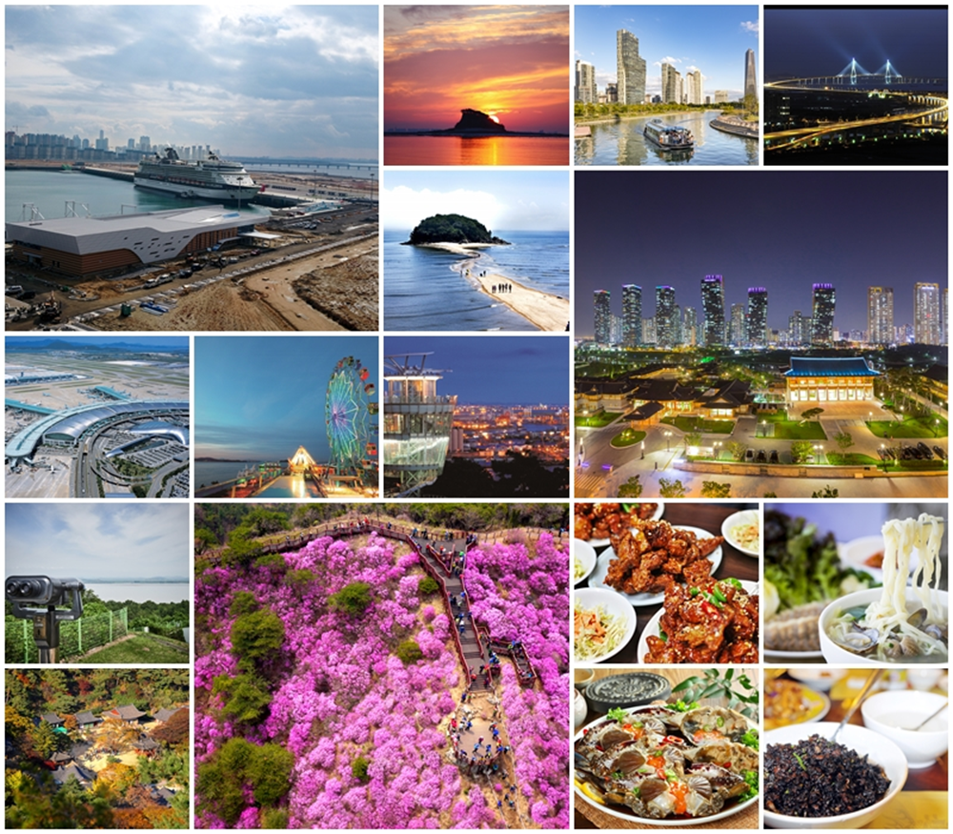

Incheon Tourism Organization (ITO)
Incheon Tourism Organization is a control tower of Incheon Tourism Industry, fully budgeted by the Incheon city government. ITO aims to promote sustainable growth of Incheon Tourism and furthermore boost local economy by strengthening the city’s brand power in cooperation with its partners.

As part of efforts to introduce Incheon International Cruise Terminal to the world and gear up for welcoming cruise ships and foreign cruise tourists to Incheon, we are planning to run a program named ‘Incheon Cruise Buddy’.

We are currently looking for Koreans and foreigners enrolled in a Korean university or living in Korea, who can actively participate in the Incheon Cruise Buddy Program. As a member of the program, you are supposed to join Incheon’s upcoming cruise events.

PROGRAM OVERVIEW
> Period of Activity: March ~ November 2019 (11 months)
> Main Activities: Online & Offline activities to promote Incheon’s upcoming cruise events
- You are expected to join at least one activity per month.
Month | Activity
March | • Attending the orientation of the Incheon Cruise Buddy Program (30th March 2019)
April | • Joining as staff of Incheon Tourism Booth to introduce Incheon attractions to the passengers of cruises  ※ The schedule is not fixed yet. It will be updated on a weekly or monthly basis.  • Attending the Opening Ceremony of Incheon International Cruise Terminal’ (26th April 2019)  ※ We will have the Launching Ceremony of Incheon Cruise Buddy Program’ on the same date.  • Posting reviews about ‘Opening Ceremony of Incheon International Cruise Terminal’ on Social Media  • Posting reviews about ‘Welcome Event for Cruises to Incheon’ on Social Media
May ~  October | • Joining as staff of Incheon Tourism Booth to introduce Incheon attractions to the passengers of cruises  ※ The schedule is not fixed yet. It will be updated on a weekly or monthly basis.  • Joining the field trip of ‘ Hello! Incheon’ for studying Incheon’s attractions and history  ※ This activity is to nurture your capability as a member of Incheon Cruise Buddy.  • Posting reviews about ‘Welcome Event for Cruises to Incheon’ on Social Media  • Sharing your talent, such as interviewing, translating, editing, taking photos, etc.
November | • Certificate Award Ceremony of the Incheon Cruise Buddy Program  ※ If you successfully complete the program, a certificate will be awarded by the CEO of Incheon Tourism Organization.

* The activities above are tentative, and more specific information will be updated on a weekly or monthly basis.

HOW TO APPLY
> Deadline: 17th March 2019
* Result Announcement- Monday, 25th March 2019
* Selected applicants will be contacted individually.

> We will select 40 people who meet the following requirements.
* Max. 4 people per nationality

> Welcome your application if you are a person
* who has much interest in the city of Incheon
* who can speak Chinese, Japanese or other languages (prerequisite : English)
* who has a personal blog or use social media such as Facebook, Instagram, YouTube, etc.

> Extra points will be given to applicants
* who study in a university located in Incheon or live in Incheon as a resident
* who have experience in translating (Korean<->Mother tongue), editing, interviewing, etc.
* who major(ed) tourism, journalism, communication, photography, design, etc.
* who can speak Korean (only for foreign applicants)

> Benefits
* Opportunities to participate in field trips and cultural events hosted by ITO
(All expenses for the field trips will be covered by ITO, such as transportation and meals.)
* Rewards for volunteering work as a member of staff
* Prizes for the best buddies showing outstanding performance
* A certificate of Incheon Cruise Buddy will be presented at the end of the program.
★ More details will be informed at the orientation on 30th March 2019.

> How to apply
* Please complete the application form and submit it to the email (ymj@into.or.kr) by 17th March 2019.

> More Information
* Program Manager: YU Minjong / Email: ymj@into.or.kr

> Incheon Buddy Facebook Group
* https://www.facebook.com/groups/incheoncruisebuddy
* You are supposed to join the group after being selected as an Incheon Cruise Buddy.

